Aplia Homework: Demand and Elasticity Week**-**5 Part-2

**1. Determining the price elasticity of demand**

The following graph shows two known points (X and Y) on a demand curve for oranges.

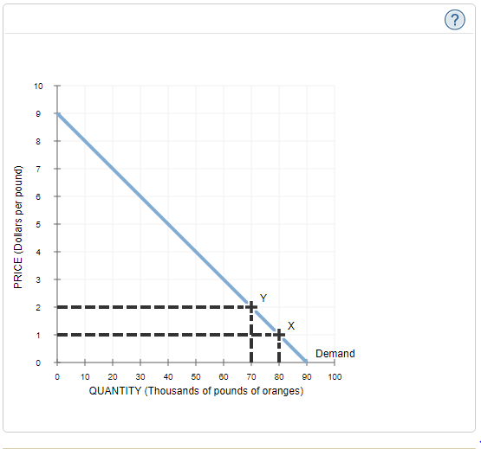

The price elasticity of demand for oranges between point X and point Y is approximately____, which suggests that the demand for oranges is____ between points X and Y.

**2. The variety of demand curves**

The following graph displays four demand curves (LL, MM, NN, and OO) that intersect at point A.

**Hint**: Select each of the points to see its coordinates.

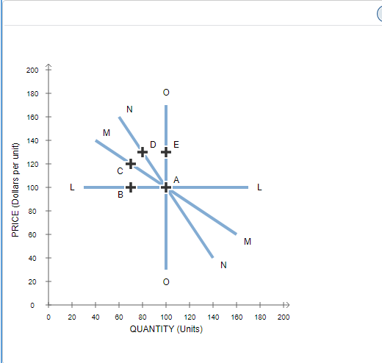

*Using the graph, complete the table that follows by indicating whether each statement is true or false.*

| **Statement** | **True** | **False** |
| --- | --- | --- |
| Between points A and D, curve NN is inelastic. | ___ | ___ |  |
| Curve NN is more elastic between points A and D than curve MM is between points A and C. | ___ | ___ |  |
| Between points A and E, curve OO is perfectly elastic. | ___ | ___ |  |

**3. Elastic, inelastic, and unit-elastic demand**

The following graph shows the demand for a good.

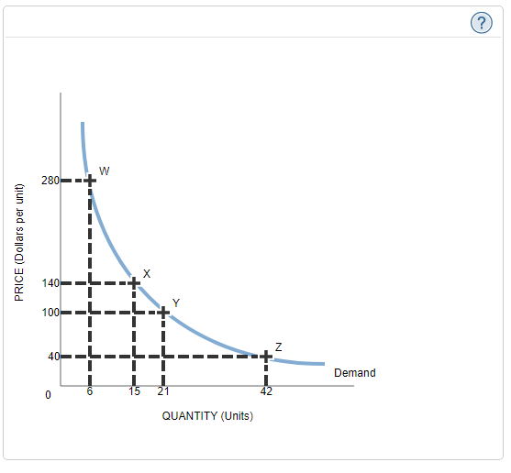

*For each region on the graph given in the following table, use the elasticity formula to identify whether the demand for this good is elastic, (approximately) unit elastic, or inelastic.*

| **Region** | **Elastic** | **Inelastic** | **Unit Elastic** |
| --- | --- | --- | --- |
| Between W and X | ___ | ___ | ___ |  |
| Between X and Y | ___ | ___ | ___ |  |
| Between Y and Z | ___ | ___ | ___ |  |

True or False: The value of the price elasticity of demand is equal to the slope of the demand curve.

True

False

**4. Elasticity and total revenue**

The following graph shows the daily demand curve for bippitybops in Philadelphia.

*Use the green rectangle (triangle symbols) to compute total revenue at various prices along the demand curve. You will use this information to answer the questions that follow.*

**Note**: You will not be graded on any changes made to this graph.

**Hint**: Select the green rectangle after you have placed it on the graph to see its area.

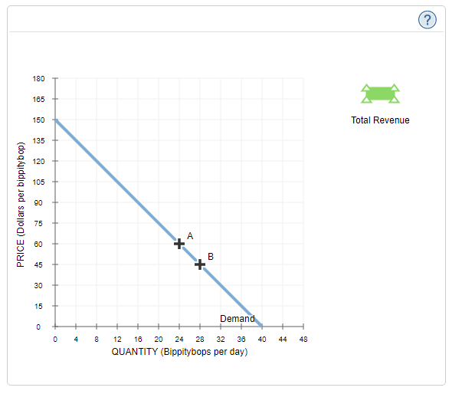

*On the following graph, use the green point (triangle symbol) to plot the daily total revenue when the market price is $30, $45, $60, $75, $90, $105, and $120 per bippitybop.*

*The price elasticity of demand between points A and B on the initial graph is approximately_____.*

*Suppose the price of bippitybops is currently $45 per bippitybop, shown as point B on the initial graph. Because the price elasticity of demand between points A and B is_____, a $15-per-bippitybop increase in price will lead to_____**in total revenue per day.*

*In general, in order for a price decrease to cause a decrease in total revenue, demand must be_____.*

***5. Determinants of the price elasticity of demand***

Consider some determinants of the price elasticity of demand:

|  |  |
| --- | --- |
| • | Nature of the good - Whether the good is a necessity or a luxury |
| • | The availability of close substitutes |
| • | How narrowly you define a good |
| • | The share consumer's budget spent on the good |
| • | The passage of time |

A good without any close substitutes is likely to have relatively____  demand, because consumers cannot easily switch to a substitute good if the price of the good rises.

A good’s price elasticity of demand depends in part on how necessary it is relative to other goods. If the following goods are priced approximately the same, which one has the most elastic demand?

Chemotherapy for cancer patients

Yacht

Price elasticity for a good depends on the share of a consumer's budget spent on a good. Other things being equal, which of the following goods has the most elastic demand?

Computer

Laundry detergent

Salt

*The price elasticity of demand for a good also depends on how you define the good.*

*Organize the goods found in the following table by indicating which is likely to have the most elastic demand, which is likely to have the least elastic demand, and which will have demand that falls in between.*

| ***Categories*** | ***Most Elastic*** | ***In Between*** | ***Least Elastic*** |
| --- | --- | --- | --- |
| *Merlot* | *___* | *___* | *___* |  |
| *Beverages* | *___* | *___* | *___* |  |
| *Wine* | *___* | *___* | *___* |  |

*The price elasticity of demand is also affected by the given time period, sometimes called the time horizon.*

*Compared to the short-run demand for oil, the demand for oil in the long run will tend to be______ elastic.*

***6. Application: Elasticity and hotel rooms***

*The following graph input tool shows the daily demand for hotel rooms at the Peacock Hotel and Casino in Las Vegas, Nevada. To help the hotel management better understand the market, an economist identified three primary factors that affect the demand for rooms each night. These demand factors, along with the values corresponding to the initial demand curve, are shown in the following table and alongside the graph input tool.*

| ***Demand Factor*** | ***Initial Value*** |
| --- | --- |
| ***Average American household income*** | *$40,000 per year* |
| ***Round trip airfare from San Francisco (SFO) to Las Vegas (LAS)*** | *$100 per round trip* |
| ***Room rate at the Grandiose Hotel and Casino, which is near the Peacock*** | *$200 per night* |

*Use the graph input tool to help you answer the following questions. You will not be graded on any changes you make to this graph.*

***Note****: Once you enter a value in a white field, the graph and any corresponding amounts in each grey field will change accordingly.*

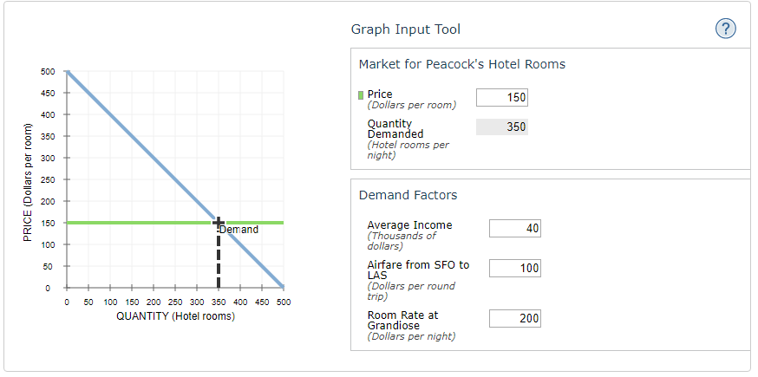

*For each of the following scenarios, begin by assuming that all demand factors are set to their original values and that Peacock is charging $150 per room per night.*

*If average household income increases by 25%, from $40,000 to $50,000 per year, the quantity of rooms demanded at the Peacock____**from____ rooms per night to____ rooms per night. Therefore, the income elasticity of demand is____, meaning that hotel rooms at the Peacock are_____.*

*If the price of a room at the Grandiose were to decrease by 20%, from $200 to $160, while all other demand factors remain at their initial values, the quantity of rooms demanded at the Peacock____**from___ rooms per night to____ rooms per night. Because the cross elasticity of demand is____, hotel rooms at the Peacock and hotel rooms at the Grandiose are______**.*

*Peacock is debating decreasing the price of its rooms to $125 per night. Under the initial demand conditions, you can see that this would cause its total revenue to____ . Decreasing the price will always have this effect on revenue when Peacock is operating on the____ portion of its demand curve.*

**7. Calculating the price elasticity of supply**

Jake is a retired teacher who lives in New York City and provides math tutoring for extra cash. At a wage of $40 per hour, he is willing to tutor 7 hours per week. At $50 per hour, he is willing to tutor 10 hours per week.

Using the elasticity formula (calculated based on average change), the elasticity of Jake's labour supply between the wages of $40 and $50 per hour is approximately____, which means that Jake's supply of labour within this wage range is_____.

**8. Finding a demand curve from historical statistics**

The citizens of Splash Ville enjoy swimming all summer long. Assume that the quantity of swimsuits demanded in a given year depends only on the average temperature that summer and the price of swimsuits. Additionally, assume that the cost of Lycra (a synthetic elastic fabric used to produce close-fitting clothing such as swimsuits) represents the great majority of swimsuit manufacturers' costs and that every other determinant of supply remains constant over this time period. The following table shows the average summer temperature and the price of Lycra in Splash Ville for each year from 1995 to 2007.

| **Year** | **Average Temp** | **Price of Lycra** |
| --- | --- | --- |
| ***(F°)*** | ***(Dollars per yard)*** |
| 1995 | 75 | 9 |
| 1996 | 80 | 10 |
| 1997 | 85 | 10 |
| 1998 | 75 | 10 |
| 1999 | 80 | 7 |
| 2000 | 90 | 8 |
| 2001 | 85 | 7 |
| 2002 | 85 | 8 |
| 2003 | 80 | 8 |
| 2004 | 80 | 13 |
| 2005 | 85 | 13 |
| 2006 | 85 | 12 |
| 2007 | 75 | 12 |
| The following diagram shows the price of swimsuits and the quantity of swimsuits sold in Splash Ville for each year from 1995 through 2007. On the following diagram, use the blue line (circle symbol) to connect all the points for which the average temperature was 80 degrees. Then use the orange line (square symbol) to connect all the points for which the price of Lycra was $12 per yard.  What does the blue line you drew represent?  ________. |  |  |

What does the blue line you drew represent?

The supply curve for swimsuits when the average temperature is 80 degrees

The demand curve for swimsuits when the price of Lycra is $12 per yard

The supply curve for swimsuits when the price of Lycra is $12 per yard

The demand curve for swimsuits when the average temperature is 80 degrees

A historical graph showing how the price of swimsuits declined over the years in question

What is the primary cause of the high price of a swimsuit in 2004 and 2005?

Wages of swimsuit manufacturers fell.

Temperatures were above average.

The price of Lycra increased.

Temperatures were below average.

Assume that this year, the average temperature is projected to be 80 degrees, and the price of Lycra is $12 per yard. From the previous diagram, the equilibrium price of swimsuits is most likely to be_____, and the equilibrium quantity is most likely to be_____.